Dependency and TPR Under the New Juvenile Code

March 31, 2014

Blackburn Conference Center
1405 Spring Street NW
Atlanta, GA 30309

schedule

8:00-9:00 Check-in
9:00-10:15 Removal and Preliminary Protective Hearings—Laurie-Ann Fallon, CWLS, GACC Board
10:15-10:30 Break
10:30-11:45 Adjudication, Disposition and Reviews, Faye McCord, CWLS, GACC Board
11:45-12:15 Break – pick up boxed lunch
12:15-1:15 Ethics, Judge Phillip Jackson, Fulton County Juvenile Court, GACC Board
1:15-1:30 Break
1:30-2:45 Permanency Hearings and Permanent Guardianship, Richard Highsmith, GACC Board
2:45-4:00 TPR, Suzanne Whitaker, CWSL, GACC Board
Adjourn

Directions
Blackburn Conference Center
1405 Spring Street NW
Atlanta, GA 30309
From the North
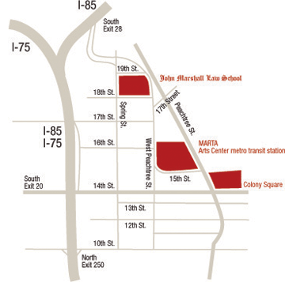
I – 85 or I-75
Take I-85 or I-75 South to the 17th St. exit – take a left onto 17th St. – at the second light, take a left (W. Peachtree St.) – go to the first light and take a left onto 18th St. – the parking deck is on the right. The Center is located directly across the street from Atlanta’s John Marshall Law School and the entrance to the building is at the corner of 18th and Spring Street.
From the South
Take I-75/I-85 North to the 10th/14th/Techwood exit (Approximately a 1/2 mile before the 75/85 split) – turn right onto 10th St. – go to the second light (W. Peachtree St.) turn left – drive eight blocks and turn left onto 18th Str. – the parking deck is on the right. The Center is located directly across the street from Atlanta’s John Marshall Law School and the entrance to the building is at the corner of 18th and Spring Street.
On Marta
Take MARTA to the Arts Center Station – exit onto W. Peachtree St. and turn right – walk three blocks and cross the street at 18th St.

Parking
There is a paid lot directly behind the conference center on Spring Street and there is also a paid lot located at the intersection of West Peachtree and 17th Street.

