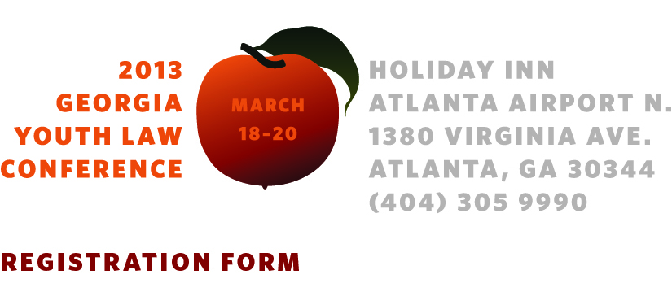Name:
Firm, Agency or Organization:
State Bar #
Street Address:
City, State Zip:
E-mail: Phone:
Practice Area (Check all that apply): Child’s Attorney/Attorney-GAL,
Parent’s Attorney, SAAG, Juvenile Defender, Other (Specify)

fees
FORMCHECKBOX GACC Member $100.00 (Must have current membership as of March 1, 2013)
FORMCHECKBOX Non-Member $200.00 (Includes 1 year membership in GACC and NACC)
FORMCHECKBOX Member Group Rate -- more than 5 individuals from the same organization (Must have current membership as of March 1, 2013) $50.00
FORMCHECKBOX Non-Member Group Rate -- more than 5 individuals from the same organization -- $100.00 (includes 1 year membership in GACC/NACC)
FORMCHECKBOX Student $50.00
FORMCHECKBOX 2012 CWLS or Presenter FREE
Subsidies

A limited number of subsidies are available for GACC members. The grant will pay the cost of hotel accommodations for members traveling more than 50 miles to the conference site. To be eligible for the subsidy you must be a current GACC member as of March 1, 2013. The deadline for subsidy requests is March 10, 2013. Subsidies will be awarded on a first-come, first served basis.

GROUP DISCOUNTS

Reduced registration rates are available for groups of more than five attendees from the same organization. Please contact Jane@GACCchildlaw.org for more information.

12.5 hours CLE (pending State Bar approval)
Including 1 hour Ethics, 1 hour Professionalism and 2 hours Trial
CLE hours earned at the 2013 Youth Law Conference may be applied to meet the 2012 MCLE requirement, without penalty
WILL YOU BE JOINING US FOR:

Lunch, Monday, March 18, 1:00-2:30 yes no

Lunch, Tuesday, March 19 12:45-2:00 yes no
Reception Tuesday, March 19, 5:00-7:00 yes no

Please describe any special dietary requirements (vegetarian options will be available).
session preferences
(CW-Child Welfare, JJ-Juvenile Justice. All-Addressed to both CW and JJ Practitioners, PA—OCA Pre-Appointment Training)
This year, the conference includes a workshop track for the required, pre-appointment training for guardians ad litem in deprivation cases. These sessions are offered by the Georgia Office of the Child Advocate and appear as Session 5 (PA) in each workshop block. PA sessions are also open to experience practitioners, but seating priority will be given to attendees seeking pre-appointment training.
Please select one session in each workshop block.
Additional information is available in the Workshop Summaries and Presenter Biographies Documents at GACCchildlaw.org

(The following Schedule is a draft and is subject to change.)
Monday, March 18
8:30 – 10:00 Registration and Check-in
10:00-11:15 Welcome and General Session 1: Commercially Sexually Exploited Children -- Widner
11:15-11:30 Break
11:30-12:45 Workshop A
Session 1 (CW) Representing Incarcerated Parents and their Children—Widner and Good
Session 2 (CW) Nuts and Bolts of ICPC—Hammond, Neeley and Carreras
Session 3 (JJ) The Changing Face of Georgia’s Juvenile Justice System – Mantz and Vignati
Session 4 (All) Understanding the Behavior and Needs of Children Affected by FASD -- Winokur
Session 5 (PA) A Team Approach to Case Preparation – Stovall, McClam, Murry, Stowe, and Mayes
1:00-2:30 Lunch -- Introduction of NEW Georgia CWLS, GACC Annual Report
2:30-3:45 General Session 2 – Representing Parents, Youth and Children with Special Needs in Juvenile Court and School Proceedings – Terry, Hetherington, Pace and Sharma

Monday, March 18, continued
3:45 - 4:00 Break
4:00 – 5:15 Workshop B
Session 1 (CW) Representing Parents and Children with Special Needs in Depriovation Cases – Terry and Hetherington
Session 2 (CW) Federal Child Welfare Policy Developments --Barclay
Session 3 (JJ) Advocating for Youth with Disabilities in Delinquency and School Disciplinary Proceedings – Pace and Sharma
Session 4 (All) TBA
Session 5 (PA) Understanding the Impact of Maltreatment on Children’s Social/Emotional Development - Doerr
5:30-7:30 Reception for GA CWLS – Sponsored by the Supreme Court Committee on Justice for Children
Tuesday, March 19
8:30-10:00 --Continental Breakfast
10:00-11:15 – General Session 3: Professionalism -- Waller
11:15-11:30 Break
11:30-12:45 Workshop C
Session 1 (CW) Representing Parents in Abuse and Neglect Cases -- Cameron
Session 2 (CW) ICWA -- Barclay
Session 3 (JJ) Evidence for Juvenile Defenders--TBA
Session 4 (All) Undocumented Youth in Juvenile Court -- Impact and Remedies in Deprivation and Delinquency Cases -- Daman
Session 5 (PA) Legal and Practical Perspectives in Implementation of a Successful Case Plan – Rambo, Kellam, and Detamore
12:45—2:00 Lunch—JLD Awards
2:00-3:15 General Session 4: Ethics -- Mathe
3:15-3:30 Break
3:30 – 4:45 Workshop D
Session 1 (CW) Practice Problem Roundtable – Carreras, et al
Session 2 (CW) Talking to Foster Youth and Parents about Intimate Relationships in the 21st Century – Walden, Walden and Good
Session 3 (JJ) Preserving the Record for Appeal -- Rogers
Session 4 (All) TBD
Session 5 (Pre-appointment) Placement Stability – Grier
5:00—7:00 Reception

Wednesday, March 20
8:30-10:00 Continental Breakfast
10:00-11:15 Workshop E
Session 1 (CW) Evidence for Child Welfare Practitioners -- Bruce
Session 2 (CW) Protecting Your Client’s Right to Appeal in Deprivation a nd TPR Cases – Cooper and Lovett
Session 3 (JJ) Developing a Theory of the Case for Juvenile Defenders -- Waldman
Session 4 (All) Social Security Benefits for Children and Families Involved in Juvenile Court Cases -- Johnson
Session 5 (PA) Money Matters – Financial Considerations GAL’s Should Explore on Behalf of the Child – Neal and Vandenberg
11:15-11:30 Break
11:30 – 12:45 General Session 5: Keeping Kids in School and Out of Court – Teske
12:45-1:00 Prize drawings
Adjourn

Return your form
By e-mail to Jane@GACCchildlaw.org and pay on-line with PayPal at GACCchildlaw.org/conferences.html
or by mail to GACC, 145 Three Oaks Drive, Athens, GA 30607, with a check made payable to GACC.

