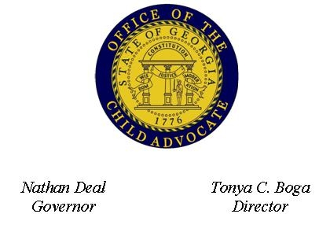 | First Witness Training Application

Applicant Information
Full Name: |  |  |  |  | Date:
 | Last |  | First | M.I.
Agency:
County:
Position:

Address:

Street Address

City State ZIP Code

Phone: |  | Email

Courses Dates and Locations
2013 Trainings
March 11-15, 2013, Savannah, Georgia

July 15-19, 2013, Gwinnett County, Georgia

September 9-13, 2013, Tifton, Georgia

Applications that contain a letter of recommendation from a supervisor and a letter from the multi-disciplinary team in our area will be given strong preference for acceptance. Please submit letters with application.

Disclaimer and Signature
The First Witness training is limited to 30 participants per session. Please be aware that this is an intensive course. Participants who fail to attend all workshops will not be awarded a certificate of course completion.
First Witness supports a multidisciplinary approach to the investigation of child abuse cases. Therefore preference will be given to those who apply as a team with a minimum of a prosecutor, law enforcement and child protective services. Individual applications will also be considered if slots are available.
You will be notified by phone or email approximately two weeks after the application deadline if you are selected for the class for which you applied. If your application is not selected for a particular course offering, you must re-apply for another offering. No applications will be automatically forwarded to the next course offering.
Note: Submission of application does not guarantee acceptance.
Signature: |  | Date:

