Dependency and TPR under the New Juvenile Code

March 31, 2014

Blackburn Conference Center
1405 Spring Street
Atlanta, GA

Name:
Firm, Agency or Organization:
State Bar #
Street Address:
City, State Zip:
E-mail: Phone:
Practice Area (Check all that apply):
Child’s Attorney/Attorney-GAL,
Parent’s Attorney, SAAG, Juvenile Defender, Other (Specify)

Fees
____GACC Member $25.00
____Non-Member $125.00
Attendees will receive a copy of Dependency and TPR sections of the GACC Checklist Guide to the Georgia Juvenile Code. Non-members will also receive a one-year membership in GACC and NACC.
Please return your registration form and payment to GACC, 145 Three Oaks Dr., Athens, GA 30607, FAX 866-610-6233

Subsidies
GACC will provide hotel rooms the night before the training (Sunday night, 3/30) for a limited number of members traveling more than 50 miles to attend the training. Requests for hotel rooms will be granted first-come, first served. To request a room, e-mail jane.okrasinski@gmail.com, and put Room Request in the subject line.

Dependency and TPR Under the New Juvenile Code

March 31, 2014

Blackburn Conference Center
1405 Spring Street
Atlanta, GA

schedule

8:00-9:00 Check-in
9:00-10:15 Removal and Preliminary Protective Hearings
10:15-10:30 Break
10:30-11:45 Adjudication, Disposition and Reviews
11:45-12:15 Break – pick up boxed lunch
12:15-1:15 Ethics
1:15-1:30 Break
1:30-2:45 Permanency Hearings and Permanent Guardianship
2:45-4:00 TPR

Directions to the Blackburn Conference Center – 1405 Spring Street
From the North
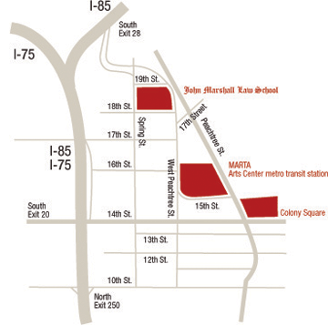
I – 85
Take I-85 South to the 17th St. exit – take a left onto 17th St. – at the second light, take a left (W. Peachtree St.) – go to the first light and take a left onto 18th St. – the parking deck is on the right. The Center is located directly across the street from Atlanta’s John Marshall Law School and the entrance to the building is at the corner of 18th and Spring Street.
I – 75
Take I-75 South to the 17th St. exit – take a left onto 17th St. – at the second light, take a left (W. Peachtree St.) – go to the first light and take a left onto 18th St. – the parking deck is on the right. The Center is located directly across the street from Atlanta’s John Marshall Law School and the entrance to the building is at the corner of 18th and Spring Street.
From the South
Take I-75/I-85 North to the 10th/14th/Techwood exit (Approximately a 1/2 mile before the 75/85 split) – turn right onto 10th St. – go to the second light (W. Peachtree St.) turn left – drive eight blocks and turn left onto 18th Str. – the parking deck is on the right. The Center is located directly across the street from Atlanta’s John Marshall Law School and the entrance to the building is at the corner of 18th and Spring Street.
From the East
Take I-20 East to I-75/I-85 North. Once on I-75/I-85 North, follow the directions above.
From the West
Take I-20 West to I-75/I-85 North. Once on I-75/I-85 North, follow the directions above.
On Marta
Take MARTA to the Arts Center Station – exit onto W. Peachtree St. and turn right – walk three blocks and cross the street at 18th St.

